New York Ceramics Fair Spotlights Contemporary Feats of Clay
January 27, 2014 2:54 PM

We asked writer Nancy Lazarus to throw herself into the New York Ceramics Fair. Here’s her well-sculpted roundup:

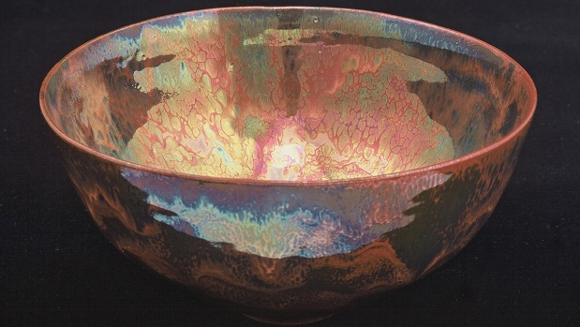
Rainbow Luster Bowl (2006), made by Haggerty Ceramics.
“With the resurgence now of porcelain and ceramics, it’s not old-fashioned love, it’s eternal love,” said designer Alexa Hampton, who was joined by fellow designers and ceramics lovers Kitty Hawks and David Scott on a panel co-sponsored by the New York School of Interior Design at the New York Ceramics Fair, held last week in the Grand Ballroom of the Bohemian National Hall.
Museum exhibits devoted to ceramics have also heralded the medium’s revival, including recent and upcoming shows at New York’s Museum of Art and Design and the Metropolitan Museum of Art. Ceramics have a long history, alternately associated with ancient rituals, children’s crafts classes, and hippies, but haven’t always been perceived in high regard.
Ceramics are now recognized as a multi-dimensional art form, as the designers pointed out. “One of the beautiful aspects of ceramics is its deep, entrenched history of usefulness,” noted Hampton, adding that one can delve into ceramics in interiors or in doses by being a collector.
Both Scott and Hawks are ceramics collectors, and Scott described the pursuit of such objects as a compulsion. Still, he noted that not every piece has to be precious. Hawks agreed that provenance is not always necessary and said ceramics preferences and tastes can be quirky.
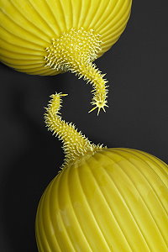A trio of contemporary American ceramicists debuted at the fair, which showcased works from 29 porcelain, pottery, glass, cloisonné, and enamel specialists, and all use innovative firing and glazing techniques and accent materials. Each hails from scenic areas of the country, and in each case their surroundings impacted their work.

Master potter Cliff Lee, from Stevens, Pennsylvania, crafted brilliantly textured prickly melons (pictured at right), a pair of which is on view at the Metropolitan Museum of Art. Made of porcelain, with incised and applied decoration under yellow glaze, they were inspired by gourds he grows in his vegetable garden, next to the 200-year-old Dutch stone barn. A former neurosurgeon, he meticulously inserted implants into the stem for texture.
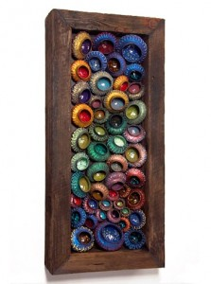Ceramic artworks of John Pagliaro of Shelter Island Heights, New York, feature stoneware with chromatic pigment, framed in reclaimed lumber. While Auzero was displayed at the fair, and Poisonous Love is pictured at left,Lazarus carried the most personal significance. That’s the first piece he created after recovering from a near-fatal moped accident while cycling on the island.

From Santa Barbara, California, James and Linda Haggerty of Haggerty Ceramics crafted the Rainbow Luster Bowl. It’s made of terra cotta with eucalyptus wood accents, using a multi-firing process in heavy reduction. James’ work has been shown at the Smithsonian, at Paris’ Museum of Decorative Arts, and in the 1989 movie Ghost. His studio was located next to Paramount Studios, and he spent two weeks training actress Demi Moore to act like she could throw on the potters’ wheel. After all, he noted that’s not enough time to properly master the process.
Hawks concurred about the difficulty of learning ceramic techniques. She said she once took a pottery class and found out how hard it is. “It involves incredible skill and dedication, and when you know what it takes to make, it enters an entirely new realm.”
Writer Nancy Lazarus is a frequent contributor to UnBeige.

